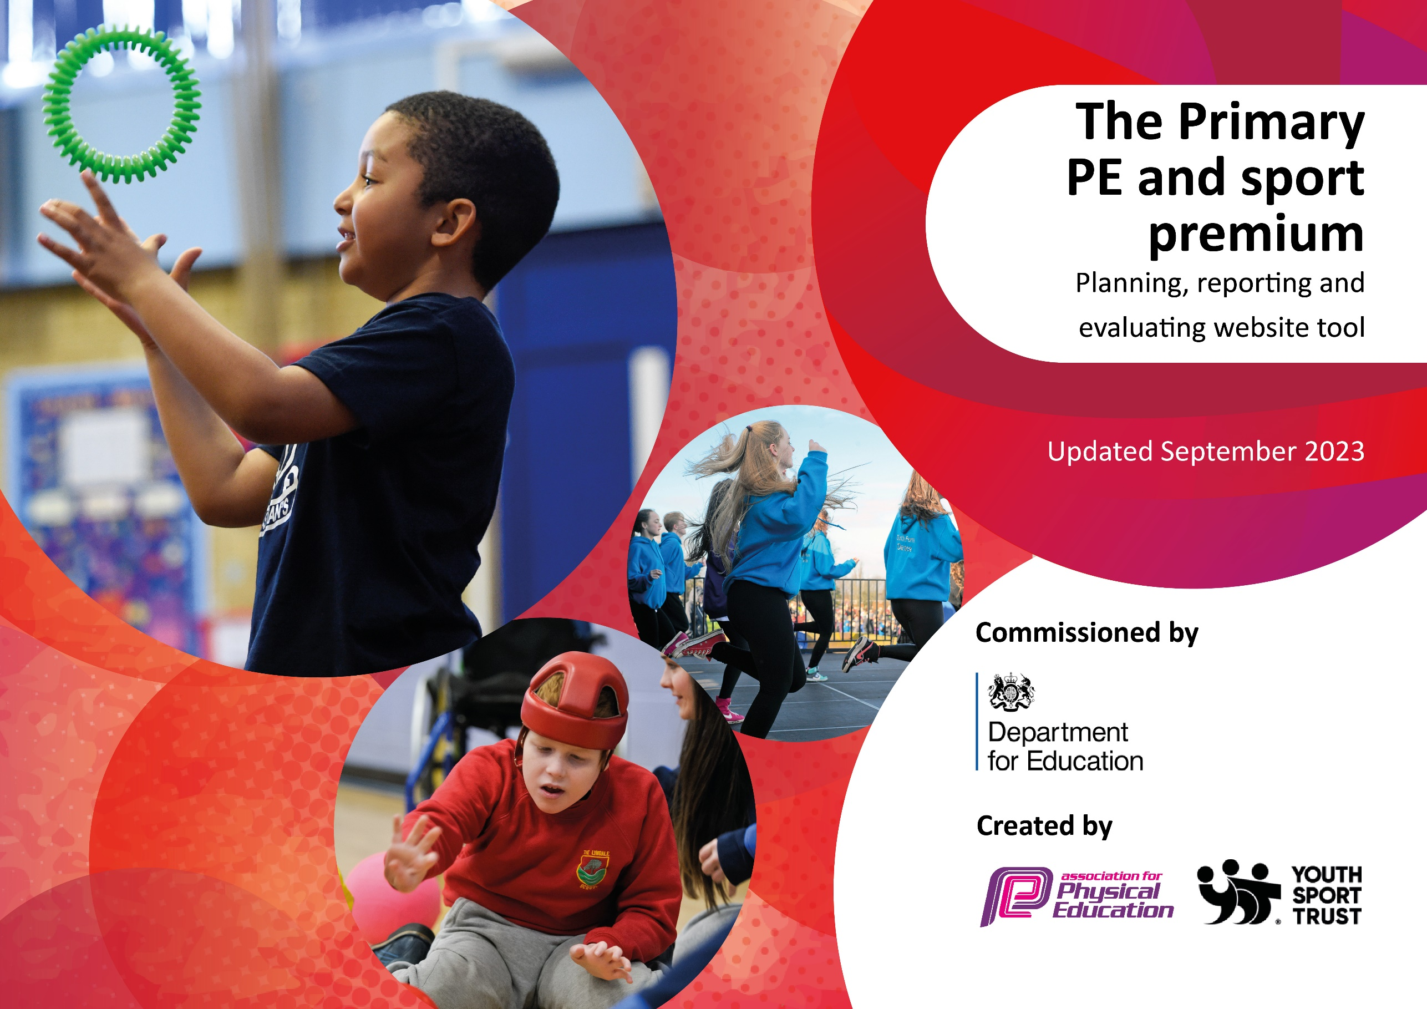

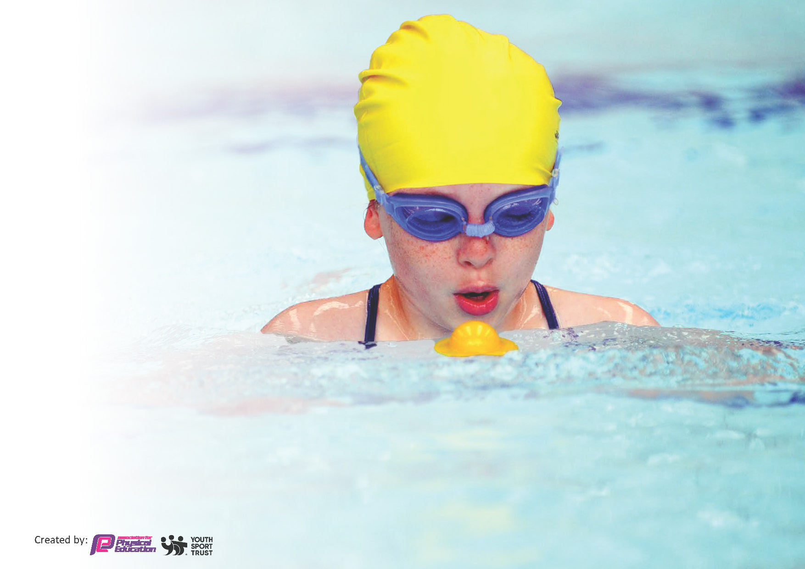
This template can be used for multiple purposes:
by:
- It enables schools to effectively plan their use of the Primary PE and sport premium
- It helps schools to meet the requirements (as set out in guidance) to publish information on their Primary PE and sport premium
- It will be an effective document to support Ofsted inspections enabling schools to evidence progress in Physical Education (PE) and evidence swimming attainment, which forms part of the PE National Curriculum. We would recommend schools consider
the Intent, Implementation and Impact of any spend, as examined within the Education Inspection Framework.

It is important that your grant is used effectively and based on school need.

Schools must use the funding to make additional and sustainable
improvements to the quality of the PE, School Sport and Physical Activity (PESSPA)
they offer. This means that you should use the Primary PE and sport premium to:

- Build capacity and capability within the school to ensure that improvements made now will benefit pupils joining the school in future years
- Develop or add to the PESSPA activities that your school already offers.

The Primary PE and sport premium should not be used to fund capital spend projects; the school’s core budget should fund these. Further detail on capital expenditure can be found in the updated Primary PE and sport premium guidance.

The Primary PE and sport premium guidance, outlines 5 key priorities that funding should be used towards. It is not

necessary that spending has to meet all the key priorities, you should select the priorities that you aim to use any funding towards.

Although completing this template is not a requirement for schools, schools are required to publish details of how they spend this funding. Schools must also outline what the impact this funding has had on pupils’ PE and sport participation and attainment and how any spending will be sustainable in the future. All funding must be spent by 31st July 2024.

The Department for Education has worked closely with the Association for Physical Education (afPE) and the Youth Sport Trust (YST) to develop this template and encourages schools to use it. This template is an effective way of meeting the reporting requirements of the Primary PE and sport premium.
Review of last year’s spend and key achievements (2023/2024)

We recommend you start by reflecting on the impact of current provision and reviewing your previous spend.

Activity/Action | Impact | Comments
Staff CPD | Staff CPD delivered by external provider supported staff in developing skills essential for high-quality teaching including applying the STEP principle to adapt lessons and effectively modelling key skills. | Further staff CPD focused around gymnastics subject knowledge to be procured.
Lunchtime clubs | Pupils experienced lunchtime club activities that promoted physical activity and saw good engagement.
After-school clubs | Pupils provided with opportunities to take part in extra-curricular physical activity on a weekly basis.
Swimming booster sessions for Y6 pupils | Increase in swimming attainment for Y6 swimming cohort. | Swimming boosters to continue on a yearly basis.
GetSet4PE Scheme X 3 years subscription | The GetSet4PE scheme has become thoroughly embedded within our school curriculum. The scheme is spoken highly of by staff members, who feel that is has improved their confidence in teaching subjects of low confidence. In addition, the high-quality lesson plans and structured progression has supported us in delivering a progressive, skills based PE curriculum. | CPD to be provided about using GETSET4PE effectively to support planning.
Equipment for PE lessons and breaktime provision | Equipment was purchased that ensured PE lessons were well resourced, promoting higher levels of engagement and physical activity during lessons. Breaktime equipment also ensured that our pupils had opportunities for physical activity at break and lunch times.
Gymnastics CPD | PE CPD for ECT staff was delivered across a half-term to support with establishing the fundamentals of effective PE teaching in gymnastics.
Playtime leader training & Lunchtime support | External specialist coach delivered play leader training program to KS2 children. Training provided pupils with ideas for new, physically active games to play and lead with their friends. | Play leaders to be identified for 24-25 academic year. Training to be provided.
Project Resurgence | Project Resurgence ballet program ran throughout the whole academic year, providing a group of Y6 children with professional grade ballet tutoring for 2 hours per week.

Key priorities and Planning
This planning template will allow schools to accurately plan their spending.

Action – what are you planning to do | Who does this action impact? | Key indicator to meet | Impacts and how sustainability will be achieved? | Cost linked to the action
Provide Y6 Swimming boosters for pupils in the Y6 cohort who did not meet national swimming standards. | Pupils | Key indicator 2 - The engagement of all pupils in regular physical activity.  Key indicator 4 – Broader range of sports and activities offered to all pupils. | Pupils who did not meet national expectation in Y4 swimming lessons will be provided the opportunity to take part in swimming booster sessions.  A greater % of pupils in the current Y6 cohort will meet the national expectation in swimming confidence. | £1000
Provide CPD in the form of a coaching model for teaching staff delivered by external agency. CPD program to be focused around providing staff with confidence required to assess pupils’ skill acquisition confidently during PE lessons. | Teaching staff  Pupils | Key Indicator 1 – Increased confidence, knowledge and skills of all staff in teaching PE and sport.  Key indicator 2 - The engagement of all pupils in regular physical activity. | External coaching agency will provide PE CPD to teachers in the form of lesson support and team-teaching.  Teachers will develop an improved knowledge of PE assessment procedures and as a result, feel more confident in assessing pupil attainment accurately.  Pupils will also benefit from the coaches input and contributions to lessons. | £2000
Begin relationship with Northern School of Contemporary Dance to promote active learning within the curriculum while providing staff CPD. | Pupils  All staff | Key Indicator 1 – Increased confidence, knowledge and skills of all staff in teaching PE and sport.  Key indicator 2 - The engagement of all pupils in regular physical activity.  Key indicator 3 – Raising the profile of PE and Sport as a tool for whole school improvement.  Key indicator 4 – Broader range of sports and activities offered to all pupils. | Northern Arts School of Contemporary Dance will deliver weekly PE sessions to all classes across school that will focus on active literacy. This will provide pupils with engaging, active opportunities to develop vocabulary, drama and oracy skills while supporting teachers with exemplary CPD. | £10,000
Provide staff CPD around the fundamental aspects of physical health and movement skills – delivered by PE partner as a half-day inset. | Teaching staff | Key Indicator 1 – Increased confidence, knowledge and skills of all staff in teaching PE and sport. | PE Partner CPD provider to deliver staff CPD in the form of a staff training session.  Staff to benefit from an increased confidence in teaching PE and be more able to deliver high-quality PE lessons. | £250
Work with external orienteering agency for support with developing orienteering and OAA provision across the school. | Teaching staff  Pupils | Key indicator 3 – Raising the profile of PE and Sport as a tool for whole school improvement.  Key Indicator 1 – Increased confidence, knowledge and skills of all staff in teaching PE and sport.  Key indicator 2 - The engagement of all pupils in regular physical activity.  Key indicator 4 – Broader range of sports and activities offered to all pupils. | External agency to support with the implementation of a high-quality scheme of learning that provides pupils with opportunities for orienteering within the curriculum.  School site to be mapped and orienteering stations/resources to be installed.  CPD to be provided for staff on how to use resources effectively and facilitate physically active cross-curricular links. | £2500
Provide transportation to tournaments to allow pupils to take part in inter-school competitions. |  | Key indicator 5 - Increased participation in competitive sport.  Key indicator 4 – Broader range of sports and activities offered to all pupils. | Transportation will allow pupils to take part in competitive events outside of the existing Gorse trust offer. | £1000
Facilitate a member of school staff in becoming qualified to teach school swimming. |  | Key Indicator 1 – Increased confidence, knowledge and skills of all staff in teaching PE and sport.  Key indicator 2 - The engagement of all pupils in regular physical activity.  Key indicator 4 – Broader range of sports and activities offered to all pupils. | Supporting member of school staff in becoming qualified to teach school swimming lessons would allow for greater control over delivery and student outcomes.  Pupils will benefit from having swimming lessons delivered by familiar adults. | £950
Provide opportunities for pupils to take part in play leader program, trained by external agency coaches. | Pupils | Key indicator 2 - The engagement of all pupils in regular physical activity.  Key indicator 3 – Raising the profile of PE and Sport as a tool for whole school improvement. | External coaches to provide KS2 play leader training, with the aim of these pupils delivering regular playtime and breaktime ‘sessions’ with their friends.  Pupils will benefit from increased knowledge of physically active games that can be played at breaktimes. | £1000
Fund a member of staff to become qualified to drive pupils to events in a minibus. This will facilitate pupil participation in competitive tournaments and opportunities. | Teaching staff | Key indicator 4 – Broader range of sports and activities offered to all pupils.  Key indicator 2 - The engagement of all pupils in regular physical activity.  Key indicator 5 - Increased participation in competitive sport. | Funding will be used to facilitate a member of staff completing the relevant courses needed to obtain a license that allows them to drive a minibus, alongside Leeds City Council’s MIDAS training.  This will allow us to access a wider variety of sports opportunities and events for years to come. | £1200

Key achievements 2024-2025
This template will be completed at the end of the academic year and will showcase the key achievements schools have made with their Primary PE and sport premium spending.

Activity/Action | Impact | Comments
Increase in extra-curricular opportunities and participation in GORSE GAMES. | A large number of pupils were provided with the opportunity to take part in external sporting events and competitive sport. This culminated in the GORSE GAMES award ceremony at the end of the year where children were rewarded for their efforts. | GORSE central transport to be utilized to reduce transport costs.
Swimming boosters | Swimming booster sessions provided for the Y6 cohort support pupils who did not meet swim England standards to make further progress in their swimming ability. | Swimming boosters to continue for next academic year.
Active Literacy CPD | Staff were provided with Active Literacy CPD for the summer term. This provided staff with confidence in using dance and expressive arts to support the development of vocabulary within the curriculum. | Northern Dance CPD to continue to run throughout the 25-26 academic year.
GETSET4PE Subscription | GetSet4PE scheme continues to support teachers in producing high-quality planning for PE lessons.
Equipment | Equipment was purchased to promote opportunities for physical activity during PE lessons, at breaktimes and during extra-curricular clubs.
SEND Provision resources | Resources purchased for SEND provision provided pupils with opportunities to develop fundamental movement skills and promoted physical activity. | Further funding to be allocated to the provision of essential SEND resources in 25-26 academic year.
Summer and Easter Sports Camps | Summer and Easter Sports camps provided pupils with the opportunity to take part in daily physical activity and develop confidence in new sports during the school holidays. This provided essential opportunities for physical activity, particularly for disadvantaged pupils.

Swimming Data
Meeting National Curriculum requirements for swimming and water safety.
Priority should always be given to ensuring that pupils can perform safe self-rescue even if they do not fully meet the first two requirements of the National Curriculum programme of study

Question | Stats: | Further context  Relative to local challenges
What percentage of your current Year 6 cohort can swim competently, confidently and proficiently over a distance of at least 25 metres? | 63% | Small Year 4 cohort with significantly low number of pupils with previous swimming experience.
What percentage of your current Year 6 cohort can use a range of strokes effectively [for example, front crawl, backstroke, and breaststroke]? | 21% | Small Year 4 cohort with significantly low number of pupils with previous swimming experience.

What percentage of your current Year 6 cohort are able to perform safe self-rescue in different water-based situations? | 98% | Small Year 4 cohort with significantly low number of pupils with previous swimming experience.
If your schools swimming data is below national expectation, you can choose to use the Primary PE and sport premium to provide additional top-up sessions for those pupils that did not meet National Curriculum  requirements after the completion of core lessons. Have you done this? | Yes | Y6 Booster swimming sessions provided in the Summer 2 half-term to boost % of pupils confident in using a range of strokes.
Have you provided CPD to improve the knowledge and confidence of staff to be able to teach swimming and water safety? | No

Signed off by:

Head Teacher: | S. Done
Subject Leader or the individual responsible for the Primary PE and sport premium: | J. Mayfield
Governor: | N. Walkley
Date: | 18/9/2024

